**WEEK-7**

**React JS HOL-12**

* **Explain about conditional rendering in React**  
  Conditional rendering in React means showing or hiding parts of the UI based on a condition. For example, if a user is logged in, show their profile; otherwise, show the login page. This is done using simple if, else, or ternary (? :) operators inside the JSX.
* **Define element variables**  
  Element variables are React variables used to store JSX. You can create them inside a function and assign them different JSX based on logic. This makes the code cleaner when switching between UI elements.

Example:

let button;

if (isLoggedIn) {

button = <LogoutButton />;

} else {

button = <LoginButton />;

}

* **Explain how to prevent components from rendering**  
  To stop a component from rendering, you can return null inside the component. This tells React to skip rendering anything on the screen for that component.

Example:

if (!this.props.show) {

return null;

}

**App.js**

import { useState } from "react";

import Greeting from "./components/Greeting";

import LoginButton from "./components/LoginButton";

import LogoutButton from "./components/LogoutButton";

function App() {

  const [isLoggedIn, setIsLoggedIn] = useState(false);

  const handleLoginClick = () => {

    setIsLoggedIn(true);

  };

  const handleLogoutClick = () => {

    setIsLoggedIn(false);

  };

  return (

    <div style={{ textAlign: "center", marginTop: "50px" }}>

      <Greeting isLoggedIn={isLoggedIn} />

      {isLoggedIn ? (

        <LogoutButton onClick={handleLogoutClick} />

      ) : (

        <LoginButton onClick={handleLoginClick} />

      )}

    </div>

  );

}

export default App;

**GuestGreeting.js**

function GuestGreeting() {

  return <h1>Please sign up. You are a Guest now.</h1>;

}

export default GuestGreeting;

**UserGreeting.js**

function UserGreeting() {

  return <h1>Welcome back. You are a User now.</h1>;

}

export default UserGreeting;

**LoginButton.js**

function LoginButton(props) {

  return (

    <button onClick={props.onClick}>

      Login

    </button>

  );

}

export default LoginButton;

**LogoutButton.js**

function LogoutButton(props) {

  return (

    <button onClick={props.onClick}>

      Logout

    </button>

  );

}

export default LogoutButton;

**Greeting.js**

import UserGreeting from "../UserGreeting";

import GuestGreeting from "../GuestGreeting";

function Greeting(props) {

  const isLoggedIn = props.isLoggedIn;

  if (isLoggedIn) {

    return <UserGreeting />; }

  return <GuestGreeting />;

}

export default Greeting;

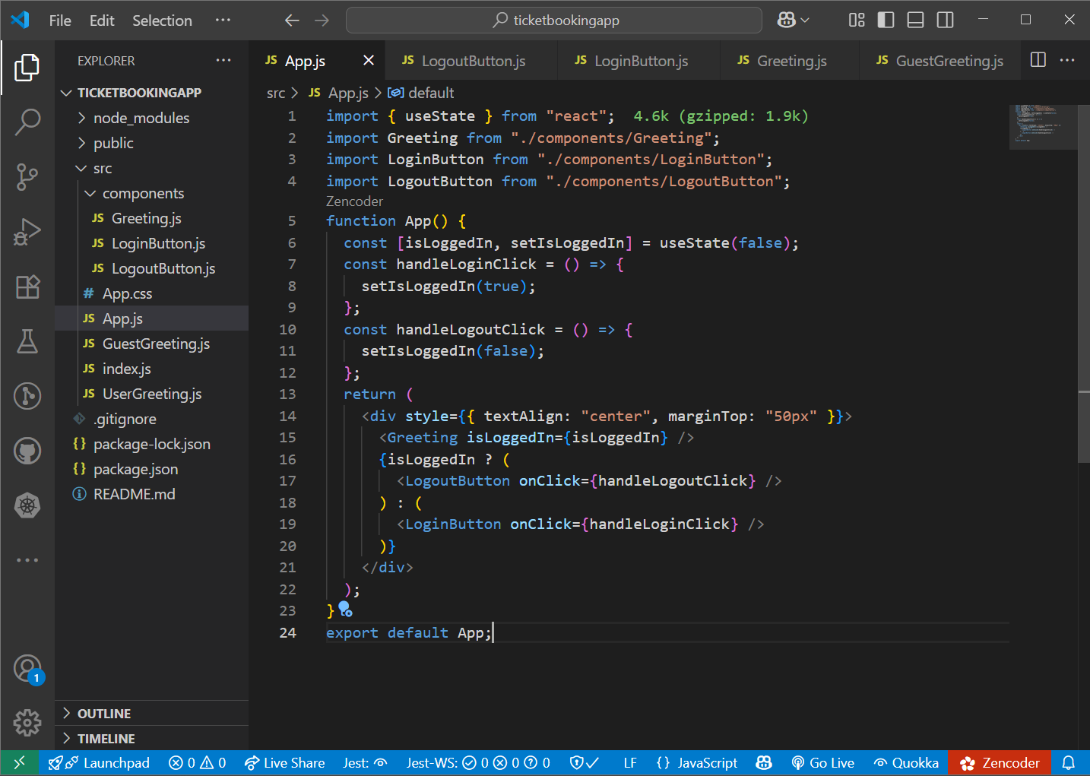

**Output:**

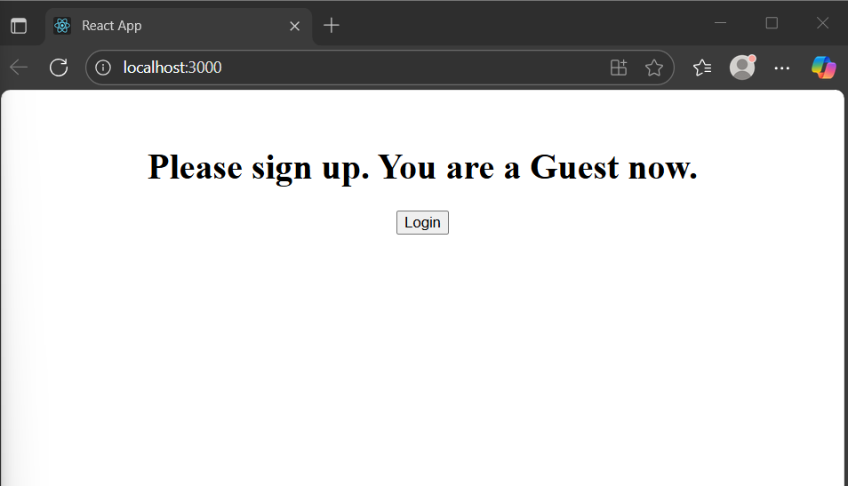

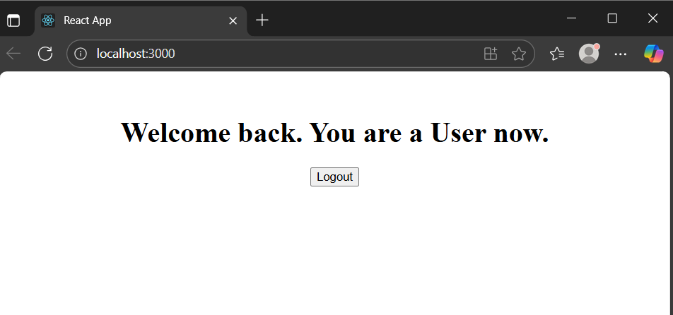

**Explanation:**

1. I created a React app named ticketbookingapp using create-react-app.
2. The app has a login/logout system managed by useState in App.js.
3. When not logged in, the user sees the Guest Page.
4. Once the user logs in, the app switches to User Page.
5. Based on the login state, buttons and content dynamically change using conditional rendering.